Geometry: Unit 11, Lesson 4
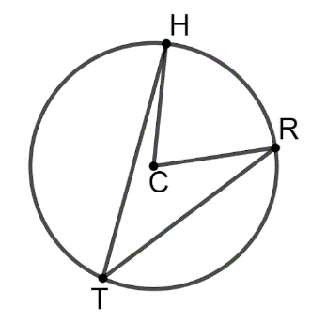
- Circle $C$ with points $H$, $R$, and $T$ on the circle is shown. What is equal to the measure of $\hat{HR}$?

$$m∠HCR$$

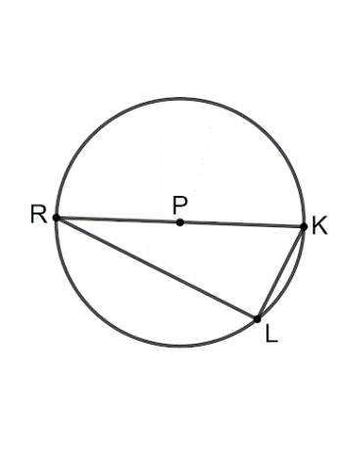
- Circle $P$ with points $R$, $K$, and $L$ on the circle is shown, where $\overline{RK}$ is a diameter. What is $m∠RLK$?

$$90°$$

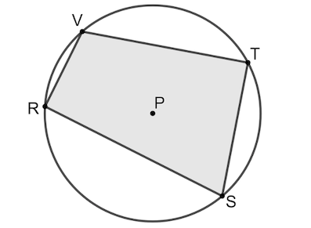
- Quadrilateral $VRST$ is shown inscribed in circle $P$. What is $m∠RVT+m∠RST$?

$$180°$$

